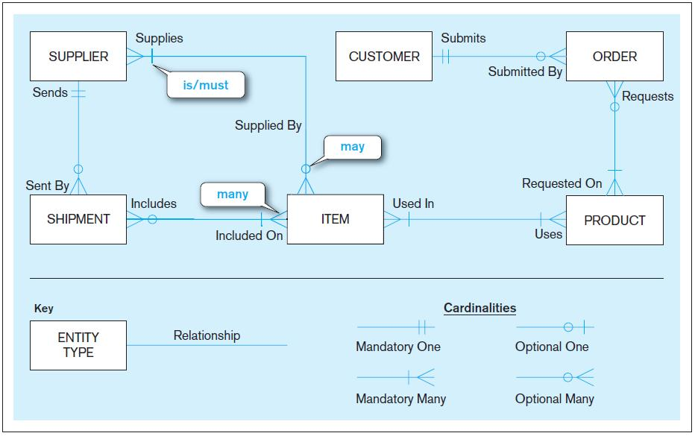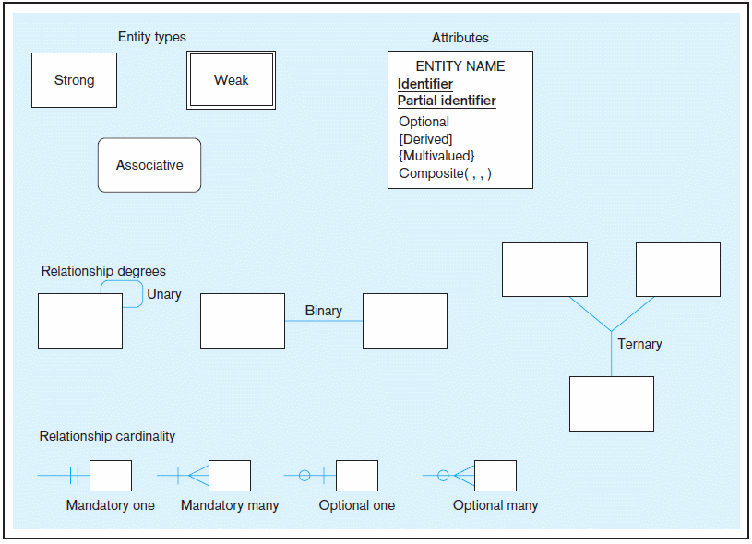

**a) Unary relationships**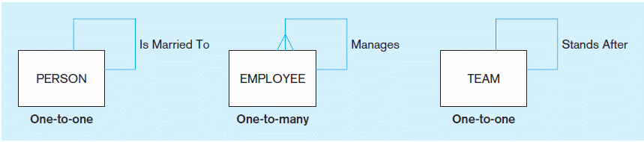

**b) Binary relationships**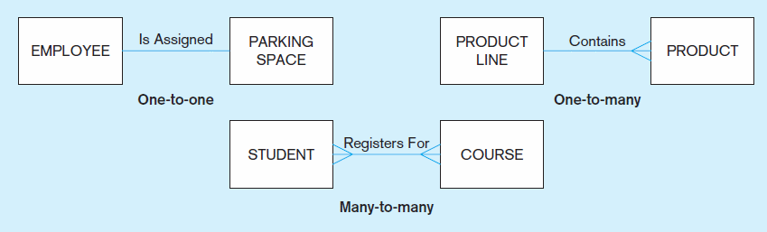

**c) Ternary relationship**

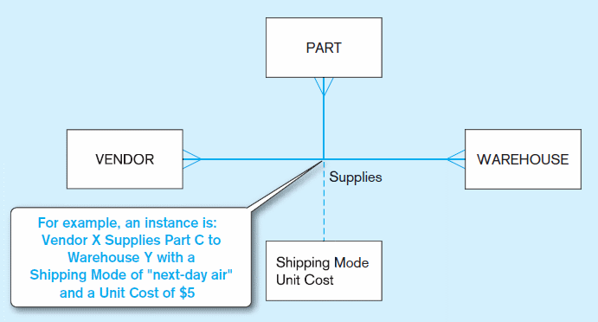

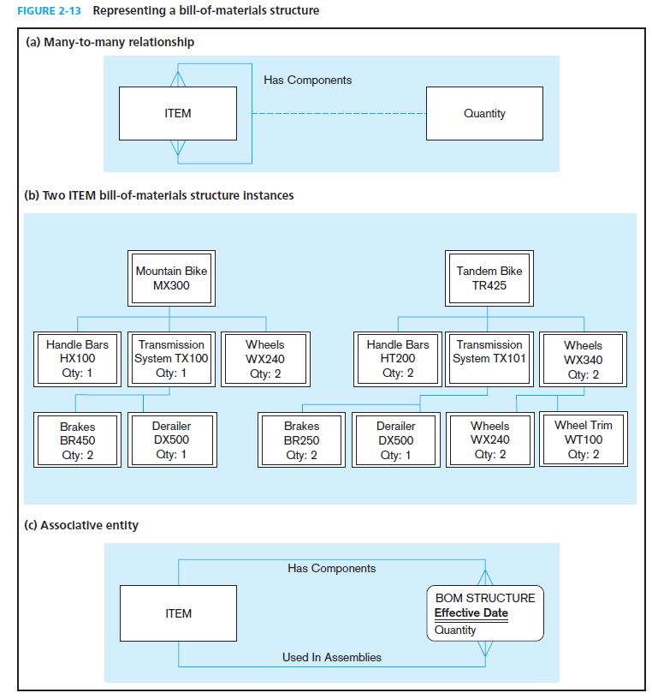

**a) Mandatory cardinalities**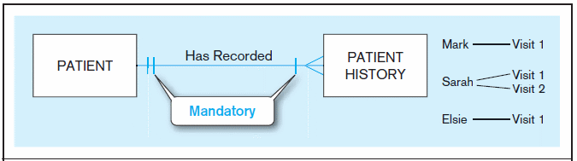

**b) One optional, one mandatory**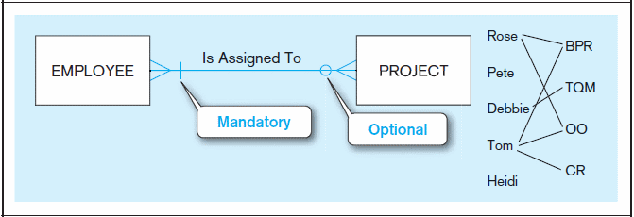

**c) Optional cardinalities**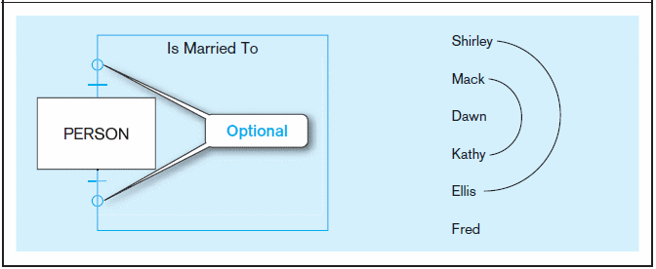

**a) Employees and departments**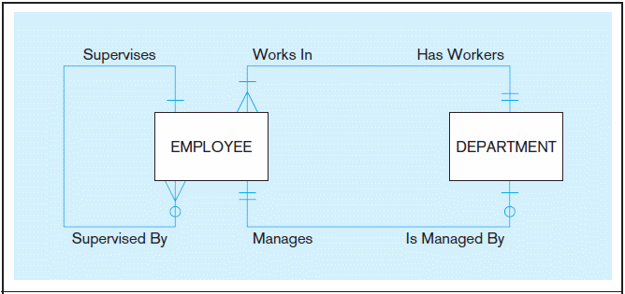

**b) Professors and courses (fixed lower limit constraint)** 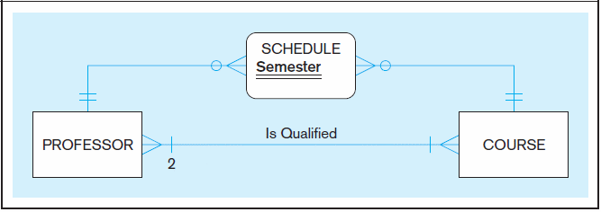

**Figure 2-18 Cardinality constraints in a ternary relationship**

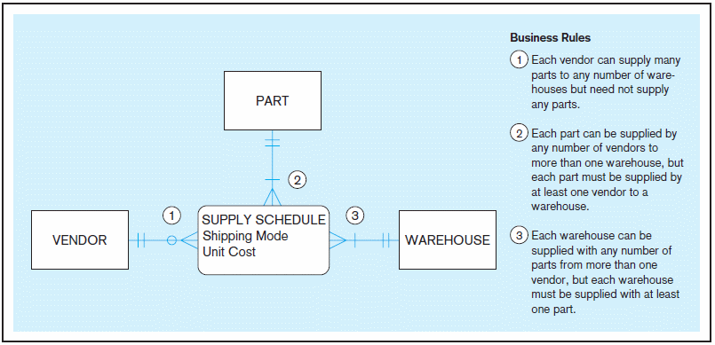

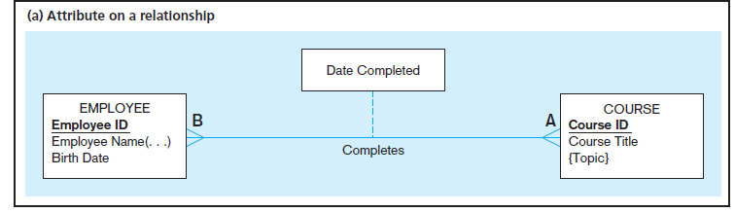 Here, the date completed attribute pertains specifically to the employee’s completion of a course…it is an attribute of the *relationship.*

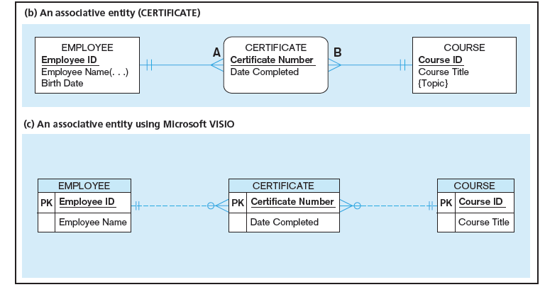 Associative entity is like a relationship with an attribute, but it is also considered to be an entity in its own right.

Note that the many-to-many cardinality between entities in Figure 2-11a has been replaced by two one-to-many relationships with the associative entity.

2-13c An associative entity – bill of materials structure

This could just be a relationship with attributes…it’s a judgment call.

**simple**

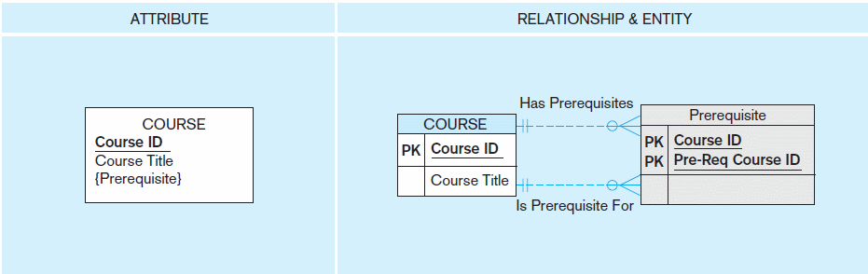

**composite**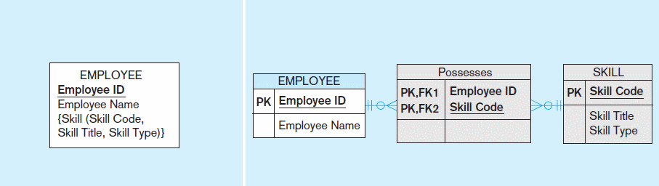

Figure 2-19 Simple example of time-stamping

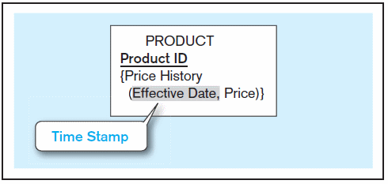

**Data model for Pine Valley Furniture Company in Microsoft Visio notation**